FSCI Painting Exhibition

Simon Worthington

2/8/23

Table of contents

# Preface

This is a Quarto book.

To learn more about Quarto books visit <https://quarto.org/docs/books>.

# 1. Paintings catalogue FSCI

Objective: Make a selection paintings for the exhibition catalogue to be selected from Wikidata and rendered multi-format in Quarto.

The below Python code uses SPARQLWrapper to retrieve data from Wikidata based on a SPARQL query.

Wikidata link: <http://www.wikidata.org/entity/Q104412992>

Creator: William Guy Wall

Inventory number: 54.90.301

Made from material(s):

Location: Metropolitan Museum of Art

Genre(s): landscape art

Depicts: river, boat, landscape art

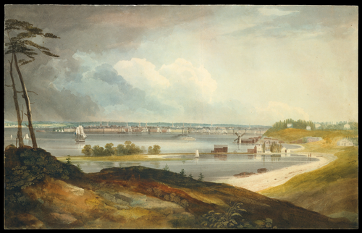

Wikidata link: <http://www.wikidata.org/entity/Q116444817>

Made from material(s):

Genre(s): landscape art

Depicts: river, mountain, waterfall

Wikidata link: <http://www.wikidata.org/entity/Q16667013>

Creator: Arkhip Kuindzhi

Inventory number: 1974.100

Made from material(s): oil paint, canvas

Location: Metropolitan Museum of Art

Genre(s): landscape art

Depicts: Sun, river, evening, Dnieper, landscape art

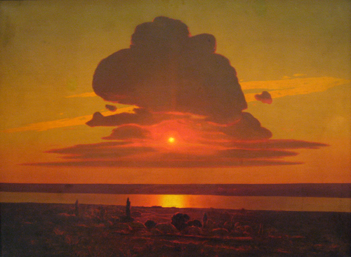

Wikidata link: <http://www.wikidata.org/entity/Q1913390>

Creator: Thomas Eakins

Inventory number: 34.92

Made from material(s): oil paint

Location: Metropolitan Museum of Art

Genre(s): portrait, landscape art

Depicts: house, river, man, tree, bridge, boat, landscape, rowing

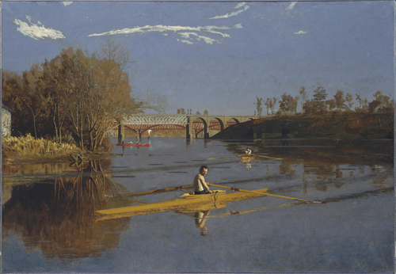

Wikidata link: <http://www.wikidata.org/entity/Q19905131>

Creator: Claude Monet

Inventory number: 29.100.110

Made from material(s): oil paint, canvas

Location: Metropolitan Museum of Art

Genre(s):

Depicts: river, tree

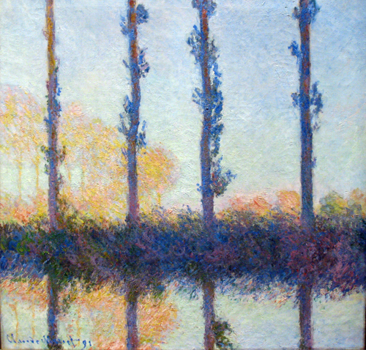

Wikidata link: <http://www.wikidata.org/entity/Q19905268>

Creator: Georges Seurat

Inventory number: 2002.62.3

Made from material(s): oil paint, canvas

Location: Metropolitan Museum of Art

Genre(s): landscape art

Depicts: house, river, tree, boat

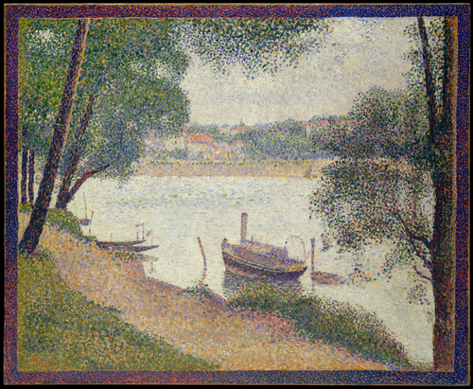

Wikidata link: <http://www.wikidata.org/entity/Q19905309>

Creator: Gustave Courbet

Inventory number: 29.100.122

Made from material(s): oil paint, canvas

Location: Metropolitan Museum of Art

Genre(s): landscape art

Depicts: river

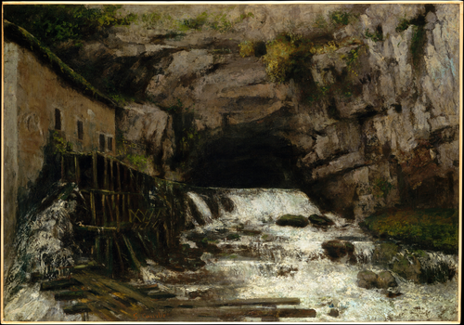

Wikidata link: <http://www.wikidata.org/entity/Q19905328>

Creator: Bernardo Bellotto

Inventory number: 39.142

Made from material(s): oil paint, canvas

Location: Metropolitan Museum of Art

Genre(s):

Depicts: woman, town, river, man, boat

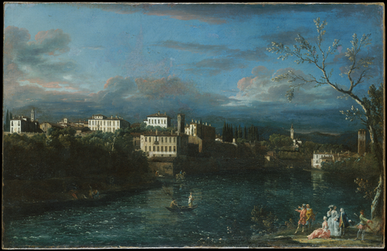

Wikidata link: <http://www.wikidata.org/entity/Q19905353>

Creator: Claude Monet

Inventory number: 29.100.108

Made from material(s): oil paint, canvas

Location: Metropolitan Museum of Art

Genre(s):

Depicts: winter, river, ice

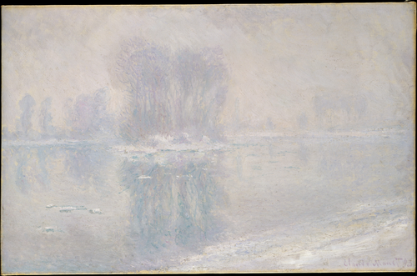

Wikidata link: <http://www.wikidata.org/entity/Q19905366>

Creator: Camille Pissarro

Inventory number: 58.133

Made from material(s): oil paint, canvas

Location: Metropolitan Museum of Art

Genre(s):

Depicts: river, Rouen, boat, port, steamboat

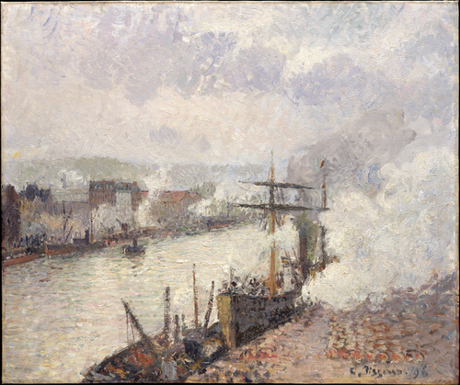

Wikidata link: <http://www.wikidata.org/entity/Q19905448>

Creator: Claude Monet

Inventory number: 51.30.3

Made from material(s): oil paint, canvas

Location: Metropolitan Museum of Art

Genre(s): landscape art

Depicts: summer, town, river, tree, landscape art

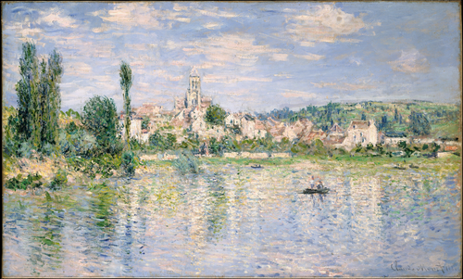

Wikidata link: <http://www.wikidata.org/entity/Q19906251>

Creator: Samuel Scott

Inventory number: 44.56

Made from material(s): oil paint, canvas

Location: Metropolitan Museum of Art

Genre(s):

Depicts: cathedral, river, bridge, boat, building

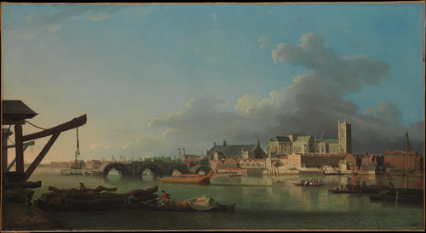

Wikidata link: <http://www.wikidata.org/entity/Q19906270>

Creator: Camille Pissarro

Inventory number: 1980.21.1

Made from material(s): oil paint, canvas

Location: Metropolitan Museum of Art

Genre(s): cityscape

Depicts: city, river, ship, bridge, Rouen, boat, port, chimney

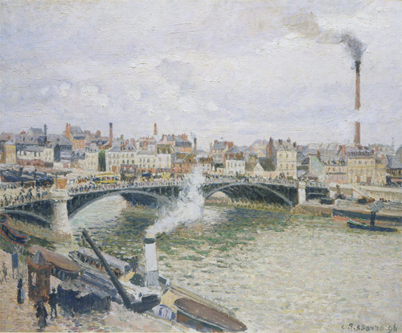

Wikidata link: <http://www.wikidata.org/entity/Q19911476>

Creator: Nicolas Poussin

Inventory number: 71.56

Made from material(s): oil paint, canvas

Location: Metropolitan Museum of Art

Genre(s):

Depicts: river, child, man, Midas

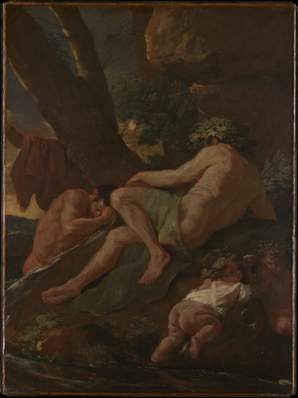

Wikidata link: <http://www.wikidata.org/entity/Q19911548>

Creator: Théodore Géricault

Inventory number: 1989.183

Made from material(s): oil paint, canvas

Location: Metropolitan Museum of Art

Genre(s): landscape art

Depicts: aqueduct, river, evening, man, landscape art

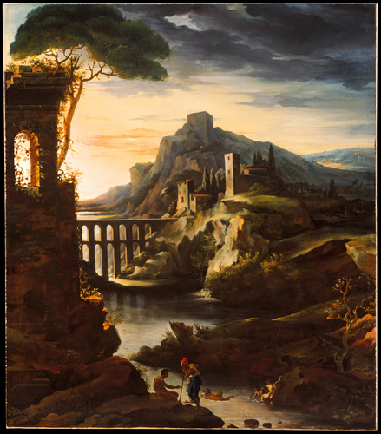

Wikidata link: <http://www.wikidata.org/entity/Q19911635>

Creator: Claude Lorrain

Inventory number: 28.117

Made from material(s): oil paint, canvas

Location: Metropolitan Museum of Art

Genre(s): landscape art

Depicts: woman, river, man, boat, landscape art

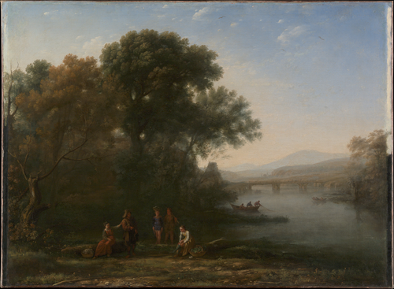

Wikidata link: <http://www.wikidata.org/entity/Q19911677>

Creator: Pierre-Henri de Valenciennes

Inventory number: 2003.42.54

Made from material(s):

Location: Metropolitan Museum of Art

Genre(s):

Depicts: river, tree

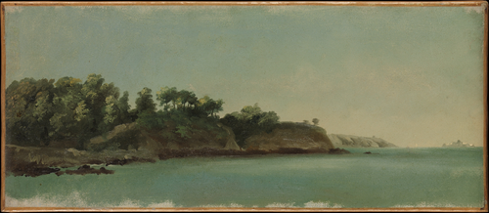

Wikidata link: <http://www.wikidata.org/entity/Q19911793>

Creator: http://www.wikidata.org/.well-known/genid/412613f48ccb2e3a893a23a2f14d6d9b

Inventory number: 2003.42.17

Made from material(s):

Location: Metropolitan Museum of Art

Genre(s): landscape art

Depicts: river, landscape art

Wikidata link: <http://www.wikidata.org/entity/Q19911819>

Creator: Paul Cézanne

Inventory number: 2001.473

Made from material(s): oil paint, canvas

Location: Metropolitan Museum of Art

Genre(s): genre art

Depicts: woman, river, man

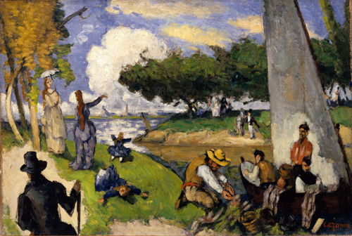

Wikidata link: <http://www.wikidata.org/entity/Q19911853>

Creator: Claude Lorrain

Inventory number: 65.181.12

Made from material(s): oil paint, canvas

Location: Metropolitan Museum of Art

Genre(s): landscape art

Depicts: cattle, river, landscape, landscape art

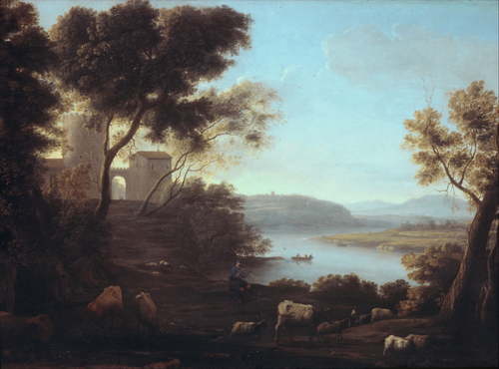

Wikidata link: <http://www.wikidata.org/entity/Q19911853>

Creator: Claude Lorrain

Inventory number: 65.181.12

Made from material(s): oil paint, canvas

Location: Olantigh

Genre(s): landscape art

Depicts: cattle, river, landscape, landscape art



Wikidata link: <http://www.wikidata.org/entity/Q19911975>

Creator: Jules Dupré

Inventory number: 67.213

Made from material(s): oil paint, canvas

Location: Metropolitan Museum of Art

Genre(s): landscape art

Depicts: dog, horse, cattle, river, equestrianism, landscape art

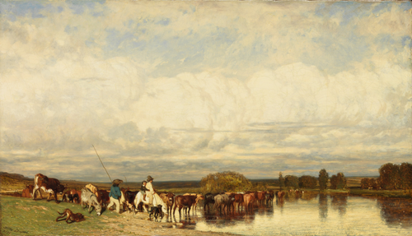

Wikidata link: <http://www.wikidata.org/entity/Q19912124>

Creator: Claude Monet

Inventory number: 67.187.88

Made from material(s): oil paint, canvas

Location: Metropolitan Museum of Art

Genre(s):

Depicts: river, Petite Creuse

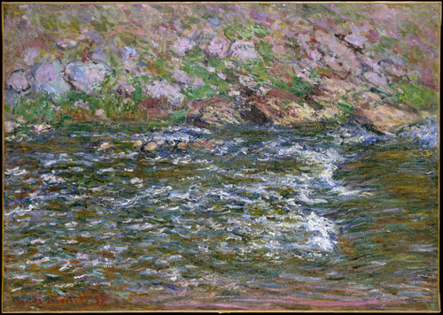

Wikidata link: <http://www.wikidata.org/entity/Q19912126>

Creator: Claude Monet

Inventory number: 56.135.6

Made from material(s): oil paint, canvas

Location: Metropolitan Museum of Art

Genre(s):

Depicts: river, boat, building, Palace of Westminster

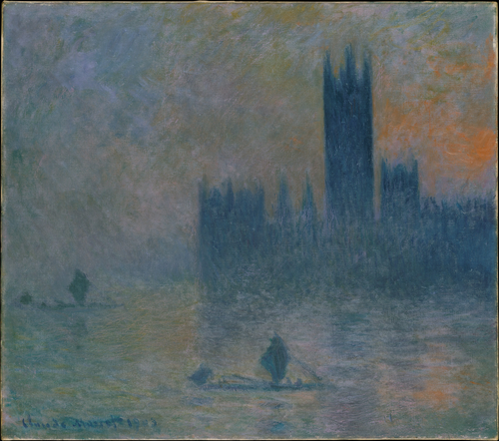

Wikidata link: <http://www.wikidata.org/entity/Q19912128>

Creator: Claude Monet

Inventory number: 56.135.5

Made from material(s): oil paint, canvas

Location: Metropolitan Museum of Art

Genre(s): landscape art

Depicts: river, landscape art

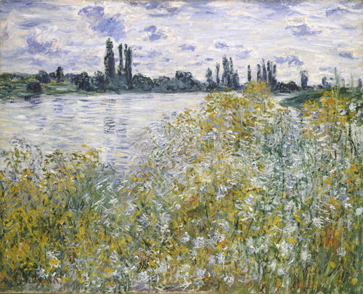

Wikidata link: <http://www.wikidata.org/entity/Q19912296>

Creator: Philip de Koninck

Inventory number: 63.43.2

Made from material(s): oil paint, canvas

Location: Metropolitan Museum of Art

Genre(s): landscape art

Depicts: river, boat, landscape art

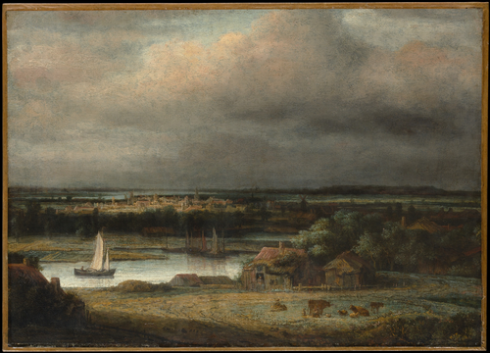

Wikidata link: <http://www.wikidata.org/entity/Q19912384>

Creator: Claude Monet

Inventory number: 56.135.4

Made from material(s): oil paint, canvas

Location: Metropolitan Museum of Art

Genre(s):

Depicts: river, morning, tree

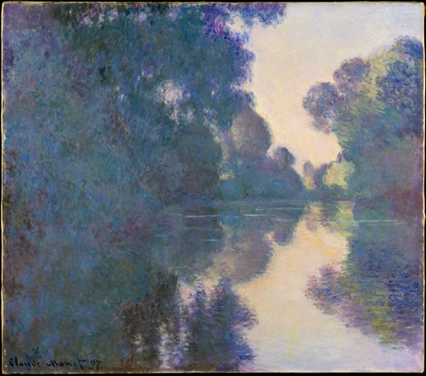

# 2. Paintings catalogue - benchmark

Objective: Make a selection of nine paintings for the exhibition catalogue to be selected from Wikidata and rendered multi-format in Quarto.

The below Python code uses SPARQLWrapper to retrieve data from Wikidata based on a SPARQL query.

Wikidata link: <http://www.wikidata.org/entity/Q203259>

Title: The Fall of the Damned

Year: 1621

Creator: Peter Paul Rubens

Copyright: public domain

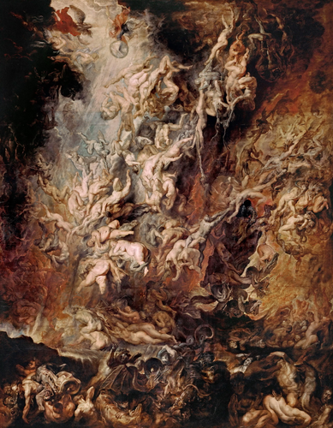

Wikidata link: <http://www.wikidata.org/entity/Q568100>

Title: The Descent from the Cross

Year: 1633

Creator: Rembrandt

Copyright: public domain

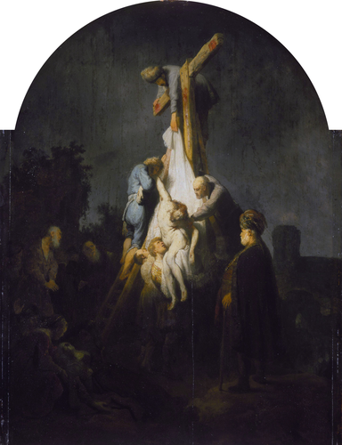

Wikidata link: <http://www.wikidata.org/entity/Q571416>

Title: Honeysuckle Bower

Year: 1609

Creator: Peter Paul Rubens

Copyright: public domain

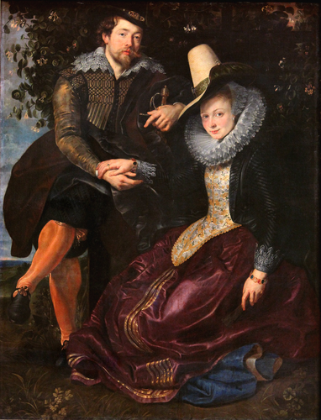

# 3. Introduction

This is a book created from markdown and executable code.

See Knuth (1984) for additional discussion of literate programming.

# 4. Summary

In summary, this book has no content whatsoever.

# References

Knuth, Donald E. 1984. “Literate Programming.” *Comput. J.* 27 (2): 97–111. <https://doi.org/10.1093/comjnl/27.2.97>.